SPAM EMAIL DETECTION SYSTEM

Project Id: 22

Name : LICHHAVI CHAUHAN (Team Leader)
Class Roll Number: 50
University Roll Number : 2028755
Section and Group: P and G2

Name : LIPIKA LATWAL
Class Roll Number: 51
University Roll Number : 2028756
Section and Group: P and G2

TABLE OF CONTENTS
- Problem Description 3
  - Dataset Description 3
  - Flow diagram 4
- Modules for Project Implementation…………………..…………………………5
  - Modules Used 5-6
  - Platform Used 7
- Machine Learning model/ Searching Technique used 8-9
- Evaluation metrics used 10
- Results and Visualizations 11-14
- Conclusion and Future Scope 15
- References 16

- Problem Description
Email spam is a major problem in digital communication, flooding inboxes with unwanted, misleading, or malicious messages. Manually filtering these emails is time-consuming and unreliable. This project aims to build an automated spam detection system using machine learning techniques. The system takes raw email text as input and processes it through a pipeline: text is cleaned by removing stop words and punctuation, then converted into numeric features using Bag of Words (Count Vectorizer) Four classification models are trained and compared — Logistic Regression and Support Vector Machine (SVM) with three kernel types: Linear, Polynomial, and RBF. Each model learns patterns from labelled email data to distinguish spam from ham (NON SPAM EMAIL) messages. Model performance is evaluated using accuracy scores and confusion matrices, providing a clear picture of each model's strengths and weaknesses .The goal is to identify the most effective algorithm for spam classification, contributing to safer and cleaner email communication.

  - Dataset Description
The dataset used in this project consists of 5,250 email messages, each labeled as either spam or ham (non-spam). It is a binary classification dataset designed for training machine learning models to detect unwanted or malicious emails.

Dataset Structure
The dataset contains 2 columns:
- Text
  - Contains the raw email message content
  - Example:
    - "Can we reschedule our Saturday call?" → Ham
    - "Your PayPal account is limited. Verify immediately..." → Spam
- Label
  - Indicates whether the email is spam or not
  - Values:
    - ham → Non-spam (legitimate email)
    - spam → Unwanted or malicious email

1.2 Flow Diagram

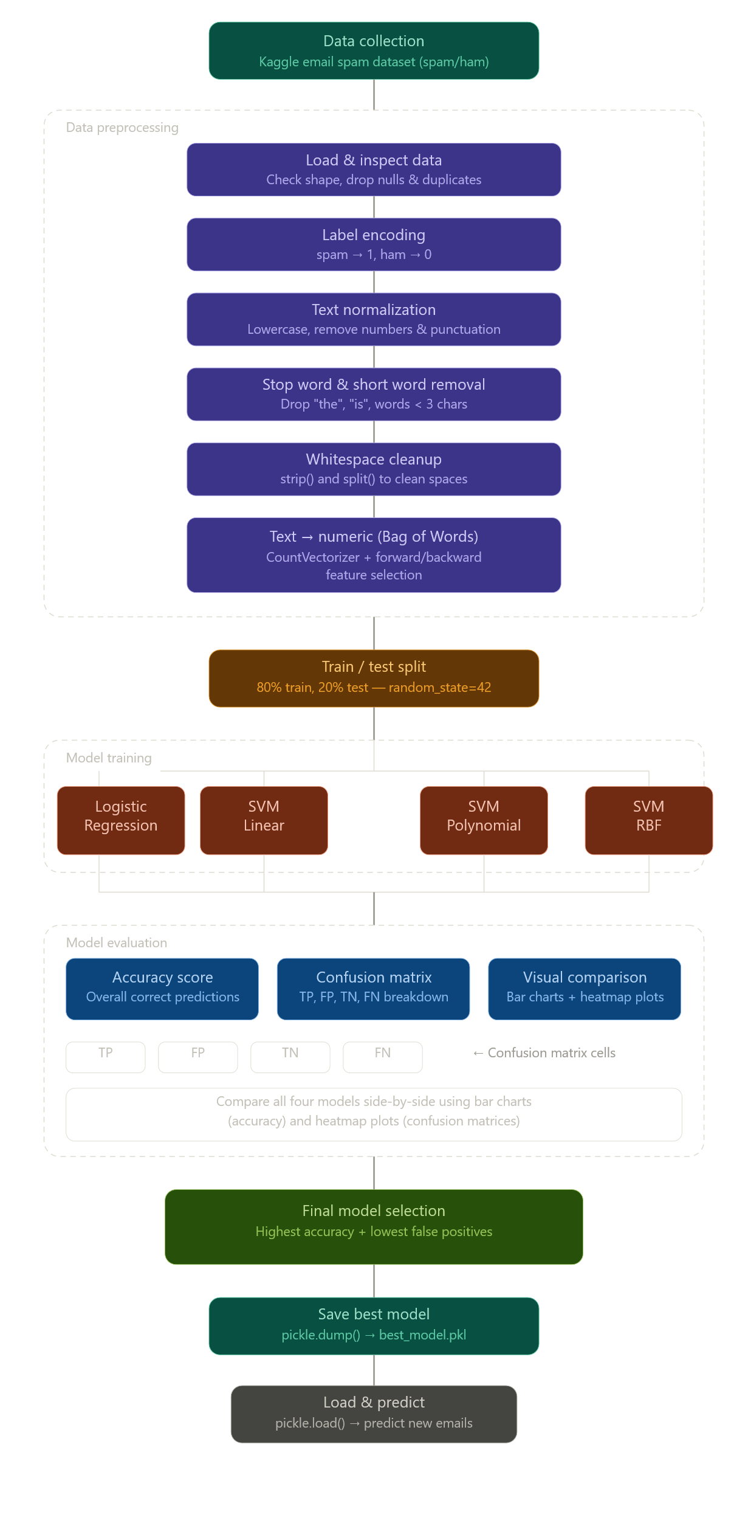

Modules for Project Implementation
1. Pandas
- Used for data manipulation and analysis
Functions used:
- pd.read_csv() → to read dataset from CSV file into a DataFrame
- DataFrame.head() → to display first few rows
- DataFrame.info() → to get dataset structure
- DataFrame.value_counts() → to check class distribution

2. NumPy
- Used for numerical computations and array operations
Functions used:
- np.array() → to create arrays
- np.linspace() → to generate values for plotting graphs

3. Matplotlib
- Used for data visualization and plotting graphs
Functions used:
- plt.figure() → to create a new figure
- plt.scatter() → to plot scatter graphs
- plt.plot() → to draw decision boundary
- plt.bar() → to plot accuracy comparison
- plt.imshow() → to display confusion matrix
- plt.xlabel(), plt.ylabel(), plt.title() → to label graphs
- plt.legend() → to show legend
- plt.show() → to display plot
4. Scikit-learn (sklearn)
- Core library used for machine learning models and evaluation
a) Model Selection
- train_test_split()
→ to split dataset into training and testing sets
b) Feature Extraction
- CountVectorizer
→ converts text data into numerical form using Bag of Words
Functions used:
- .fit() → learns vocabulary from training data
- .transform() → converts text to vectors
- .fit_transform() → performs both steps together

c) Machine Learning Models
i. Logistic Regression
- Used for binary classification
Functions used:
- .fit() → trains the model
- .predict() → predicts output

ii. Support Vector Machine (SVM)
- Used for classification with different kernels
Models used:
- SVC(kernel='linear') → Linear SVM
- SVC(kernel='poly') → Polynomial SVM
- SVC(kernel='rbf') → RBF SVM
Functions used:
- .fit() → trains the model
- .predict() → makes predictions

d) Evaluation Metrics
- Used to measure model performance
Functions used:
- accuracy_score() → calculates accuracy
- confusion_matrix() → shows prediction results

5. String / Text Processing (optional if used)
- Used for cleaning text data
Functions used:
- .lower() → convert text to lowercase
- .replace() → remove punctuation
- .split() → tokenize text

6. Stopwords (if used from NLTK)
- Used to remove common words that do not add meaning
Functions used:
- stopwords.words('english') → get list of stopwords

2.2 Platform Used: (mention all the platforms with the reason of using it)
• Jupyter Notebook
- Jupyter Notebook is used as the primary development platform for implementing the spam detection system.
Reason for using:
- Provides an interactive environment to write and execute code step-by-step
- Allows combining code, output, and explanations in a single document
- Helps in visualizing results easily (graphs, confusion matrix, etc.)
- Useful for debugging and testing models incrementally
- Supports multiple libraries like Pandas, NumPy, and Scikit-learn efficiently

- Machine Learning Model/ Searching Technique Used(Describe each ML model/ searching technique used)
This project uses multiple machine learning models to classify emails as spam or ham (non-spam). The models are trained on numerical features generated using the Bag of Words (Count Vectorizer) technique.

1. Logistic Regression
Description:
Logistic Regression is a supervised machine learning algorithm used for binary classification problems. It predicts the probability that a given input belongs to a particular class (spam or ham).
How it works:
- Uses a mathematical function called the sigmoid function
- Converts input values into probabilities between 0 and 1
- Classifies:
  - Output ≥ 0.5 → Spam
  - Output < 0.5 → Ham
Why used:
- Simple and efficient
- Works well for text classification
- Provides fast and accurate results

2. Support Vector Machine (SVM)
Description:
Support Vector Machine is a powerful supervised learning algorithm used for classification. It works by finding the optimal hyperplane that separates different classes with the maximum margin.

a) SVM – Linear Kernel
Description:
- Used when data is linearly separable
- Draws a straight line (or hyperplane) to separate spam and ham
Why used:
- Fast and efficient
- Works well for high-dimensional data like text

b) SVM – Polynomial Kernel
Description:
- Used when data is not linearly separable
- Maps data into higher dimensions using polynomial functions
Why used:
- Can capture more complex relationships
- Useful when simple linear separation is not enough

c) SVM – RBF (Radial Basis Function) Kernel
Description:
- Most commonly used SVM kernel
- Maps data into higher-dimensional space using a Gaussian function
- Creates flexible decision boundaries
Why used:
- Handles complex and non-linear data
- Provides high accuracy in many real-world problems

3. Feature Extraction Technique
Bag of Words (Count Vectorizer)
Description:
- Converts text data into numerical form
- Creates a vocabulary of all unique words
- Counts frequency of each word in a message
Example:
- Text: "win free money"
- Converted to: [1, 1, 1] (word counts)
Why used:
- Simple and effective for text classification
- Works well with machine learning models

Model Comparison
All models are evaluated using:
- Accuracy Score → measures overall correctness
- Confusion Matrix → shows correct and incorrect predictions

- Evaluation metrics used (Describe each evaluation metric used along with formulae)
1. Confusion Matrix
Description:
A confusion matrix is a table used to evaluate the performance of a classification model by comparing actual and predicted values.
 | Predicted Ham | Predicted Spam
Actual Ham | TN | FP
Actual Spam | FN | TP
Where:
- TP (True Positive): Spam correctly classified as spam
- TN (True Negative): Ham correctly classified as ham
- FP (False Positive): Ham incorrectly classified as spam
- FN (False Negative): Spam incorrectly classified as ham

2. Accuracy
Description:
Accuracy measures the overall correctness of the model.
$$Accuracy=\frac{TP+TN}{TP+TN+FP+FN}$$
Interpretation:
- Higher accuracy means better overall performance
- In your project, accuracy is very high (~99.8%)

3. Precision
Description:
Precision measures how many predicted spam emails are actually spam.
$$Precision=\frac{TP}{TP+FP}$$
Interpretation:
- High precision → fewer false positives
- Important in spam detection to avoid marking important emails as spam

4. Recall (Sensitivity)
Description:
Recall measures how many actual spam emails are correctly identified.
$$Recall=\frac{TP}{TP+FN}$$
Interpretation:
- High recall → fewer spam emails missed
- Important to catch most spam messages

5. F1 Score
Description:
F1 Score is the harmonic mean of precision and recall. It balances both metrics.
$$F1=2⋅\frac{Precision⋅Recall}{Precision+Recall}$$
Interpretation:
- Useful when there is class imbalance
- Gives a single measure of model performance

- Results and Visualizations
- 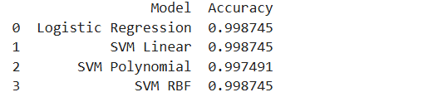
- Fig1. All four models accuracy

- 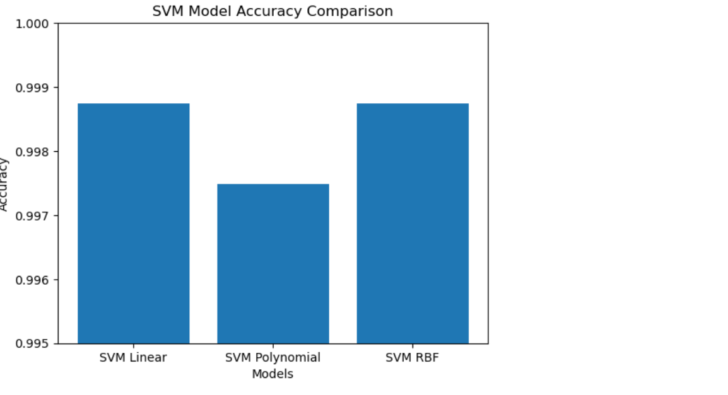

- Fig2.SVM model accuracy comparsion
- 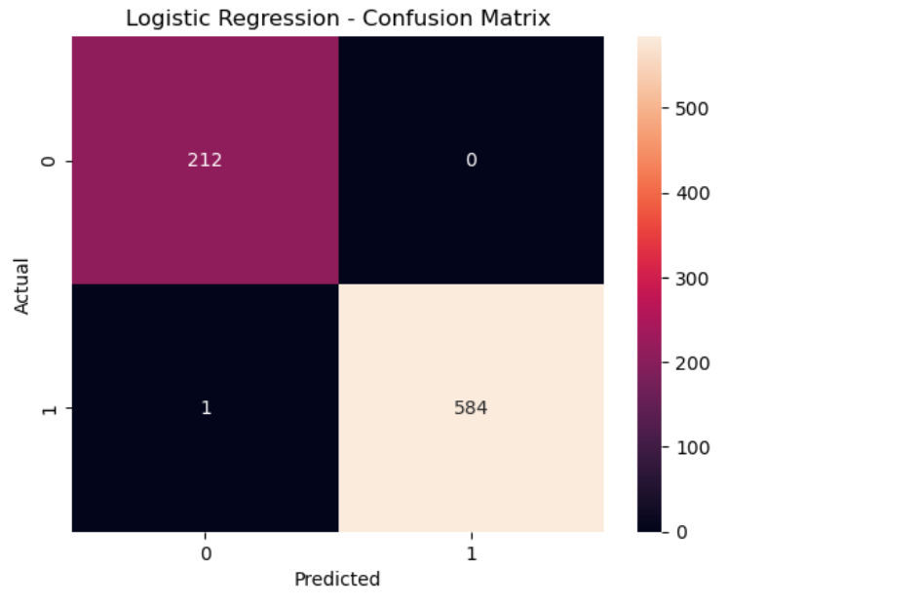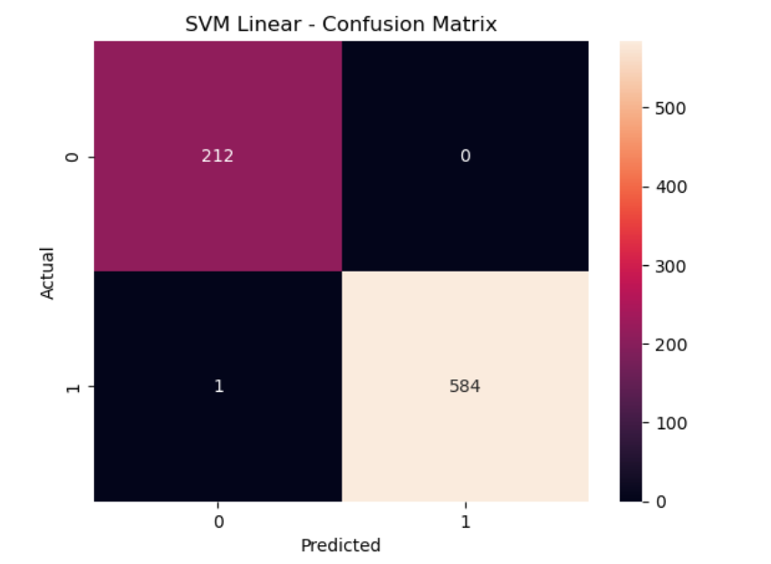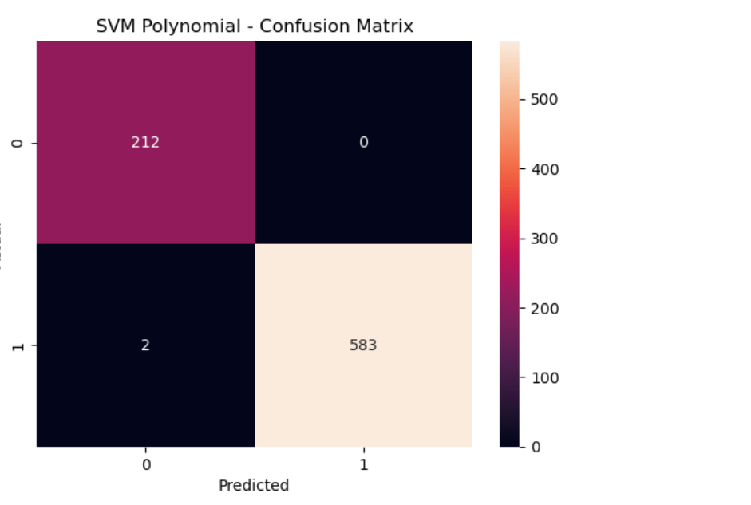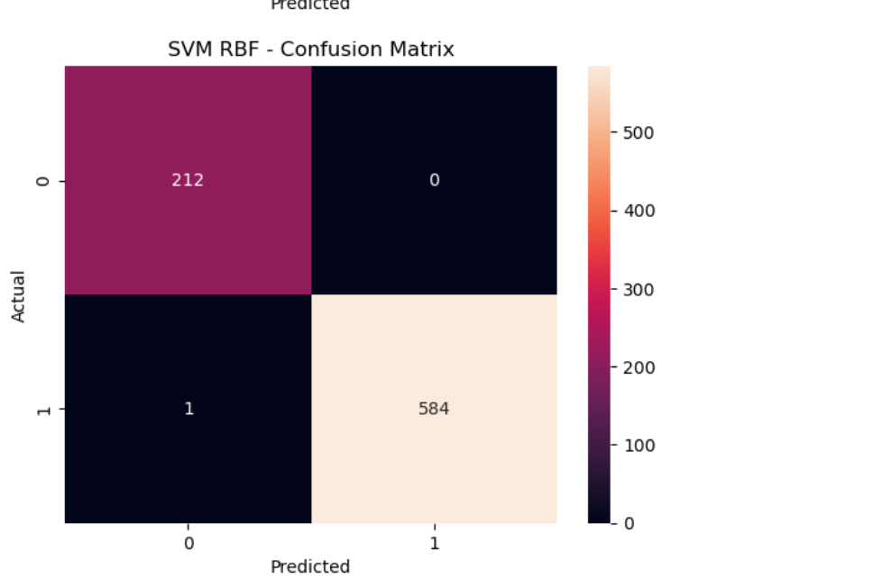

- Fig 3. Heatmap of all four models

- 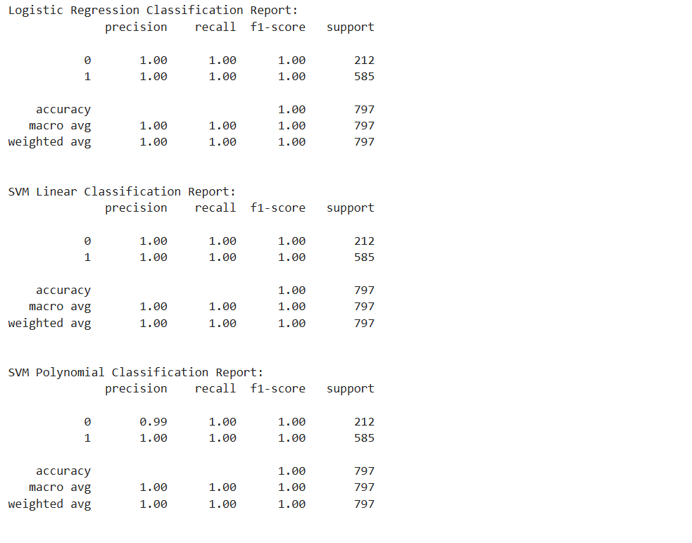

- 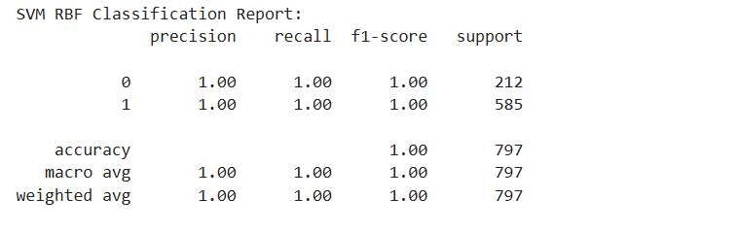

- Fig4 : classification report all models

6. Conclusion and Future Scope:
Conclusion
In this project, an automated email spam detection system was successfully developed using machine learning techniques. The system processes raw email text, performs preprocessing, and converts it into numerical features using the Bag of Words (Count Vectorizer) approach.
Multiple classification models were implemented and compared, including:
- Logistic Regression
- Support Vector Machine (SVM) with Linear, Polynomial, and RBF kernels
The performance of these models was evaluated using accuracy scores and confusion matrices. The results showed that:
- Logistic Regression and SVM (Linear and RBF) achieved very high accuracy (~99.8%)
- The models produced almost zero false positives, ensuring that legitimate emails are not misclassified as spam
- Only a very small number of spam emails were missed
Overall, the system demonstrates high reliability and effectiveness in distinguishing between spam and ham emails, making it suitable for real-world applications.
Future Scope
- Use advanced techniques like TF-IDF or deep learning (LSTM, BERT)
- Implement real-time spam filtering
- Support multiple languages
- Improve detection of phishing and advanced spam

7. References:
Books:
- Artificial intelligence and machine learning – S. CHAND

Online Resources:
https://scikit-learn.org/stable/modules/generated/sklearn.feature_extraction.text.CountVectorizer.html
https://www.geeksforgeeks.org/bag-of-words-bow-model-in-nlp/

